Name of Event: State-Level Workshop on Gender Training & Gender Justice
Date: 13th & 14th Oct. 2022
Venue: Saptrishi Sewa Bhavan, Tupudana, Ranchi
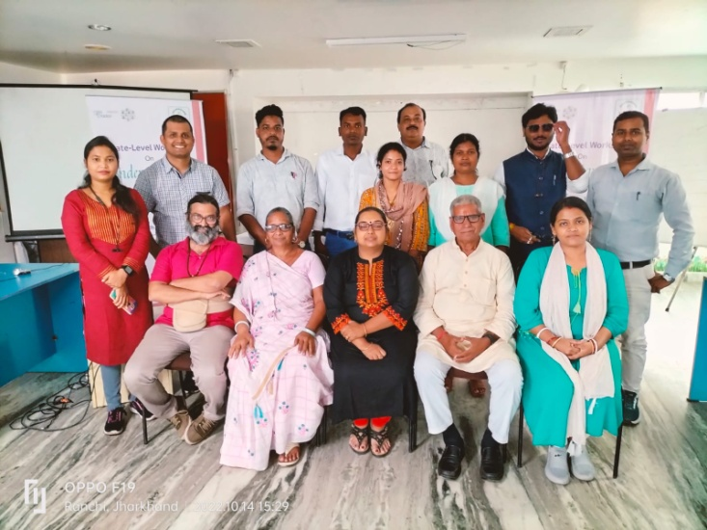
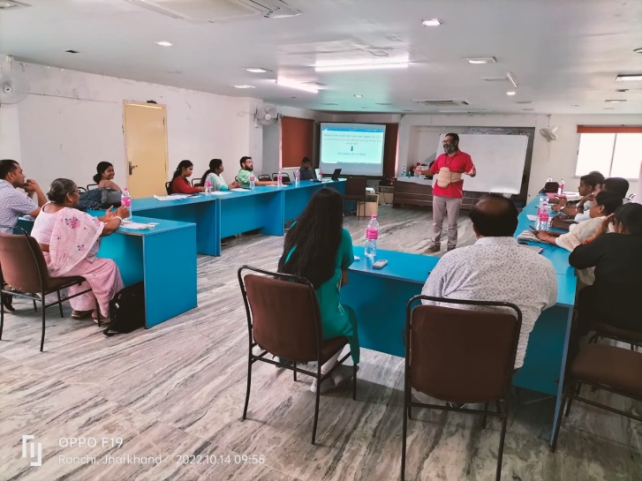
A Two-days gender training was organized by PRADAN and CSO Forum to orient various CSO representatives on this thematic area. Chief functionaries and their representatives from across the state participated in the same. Mr. Ananad Pawar a renowned trainer from Pune facilitated this workshop. Various themes like gender and sex, gender discrimination, gander equity and equality along with the concept of gender justice was discussed in this workshop. About 30 participants actively shared their views and the facilitator Mr. Pawar tried to bring all on the same platform by citing day to day examples in this gender learning workshop.

